SPRING AWARD Report [2018, December]
Daniel Warren
Name:
Thesis Title:
The Ecological Impact of Invasive Freshwater Predators upon Native Amphibians
Supervisor, School and Faculty:
Fig. 1 – Setup of experimental arenas and video recording equipment for the lab-based prey preference experiment
Dr Alison Dunn and Dr Chris Hassall, School of Biology, Faculty of Biological Sciences
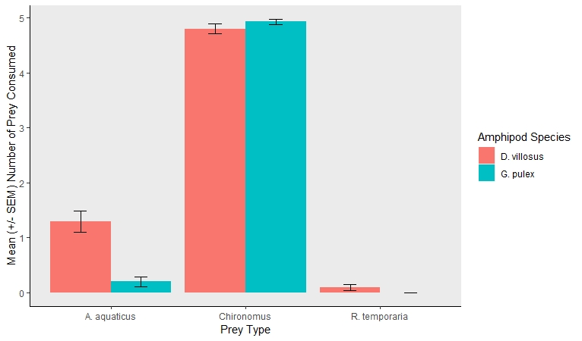
The general aim of the project: The invasive amphipod Dikerogammarus villosus currently inhabits several large freshwater bodies throughout Great Britain. However, D. villosus is expected to spread to smaller freshwater habitats such as ponds – ideal habitat utilised by endangered amphibians and other native taxa as breeding sites. Given the voracious nature of D. villosus, consuming a wide range of native species, the expected introduction of this invader into smaller freshwaters, may significantly disrupt the fragile structure of native pond communities.
The primary aim was to compare the predatory impact of the invasive D. villosus, and native amphipod Gammarus pulex, towards focal indigenous early-stage amphibians (Rana temporaria), as well as alternative native, invertebrate prey species (Asellus aquaticus and Chironomus larvae), when presented in multi-prey community modules.
The main challenges: This project was initially proposed as a field-based mesocosm study – simulating native pond communities as accurately as possible. We hoped to simulate realistic invasions, with the number of D. villosus introduced into mesocosms reflecting known field densities (~400 individuals/m²). However, an absence of heavy rainfall during winter (2018) caused a dramatic drop in water levels across UK freshwater sites, resulting in significant declines in native and invasive field populations, preventing adequate numbers of predators (and prey) from being collected. High spring temperatures also had an adverse effect on amphibian breeding, resulting in significant reductions in the amount of R. temporaria spawn being produced, compared to previous years. As such, the proposed field-based mesocosm study could not be carried out. Instead a lab-based project was designed, utilising microcosms consisting of fewer native/invasive organisms, representing a proportion of natural pond communities (Fig. 1).
The focus challenge that you are addressing (the smaller bit from the grand challenge): Invasions of large freshwaters by D. villosus have significantly alterated native community structuring, via intense predation upon a wide range of native species. Ponds typically contain diverse, yet isolated communities, vulnerable to pollution, drought, and biological invasions. Given the devastating effect that D. villosus has upon larger freshwaters, we expect that invasions into ponds may have a greater relative impact, affecting a greater taxonomic range including amphibians which rely upon ponds as breeding sites. Several UK amphibian species are of great conservation concern, hence the potential introduction of invasive D. villosus may pose a credible risk. The current study provided the ideal opportunity to investigate these potential risks towards native amphibians, as well as other native pond species.
What tools you have used and will use: To better understand predatory behaviours of native and invasive amphipods, arenas were recorded using high-definition cameras. By using motion-tracking software we hope to determine whether invasive D. villosus express selective feeding or indiscriminate feeding – and how these feeding patterns might impact upon native early-stage amphibians. We also hope to apply complex ecological models to predict how future invasion by invasive D. villosus into pond communities may impact upon native community composition and stability.
What the expected outcomes are: We expected invasive D. villosus to exhibit more diverse feeding behaviours, consuming a greater number of prey species. By comparison, native G. pulex would be systematic when selecting prey to consume. We also predicted that overall D. villosus would consume a greater number of prey, in total.
What the actual outcomes were: We confirmed that D. villosus consumed significantly more prey overall, compared to native G. pulex. Interestingly, both amphipods exhibited selective feeding hierarchies (Fig. 2). Both demonstrated significant preference for Chironomid larvae, above A. aquaticus and R. temporaria larvae – although predation of Chironomus larvae did not differ significantly between amphipods. Both amphipods showed preference in consuming A. aquaticus as an intermediate prey type, with D. villosus consuming significantly more. Conversely, only invasive D. villosus consumed R. temporaria larvae – although when compared to the other prey types, R. temporaria was the least preferred.
How the SPRING award funds assisted you in reaching your goal for this particular project? The SPRING fund was used to rent multiple high-definition cameras; used to capture and record experimental arenas. The fund was also used to rent several industrial incubators for approximately 12 weeks to store and maintain native R. temporaria spawn, collected from a number of freshwater sites throughout Yorkshire.
Why you will recommend PGRs at the water@leeds DRTC to apply to the SPRING funds: As someone for whom applications for research grants has been a necessity throughout my doctoral research, I understand that receiving research funds can be quite challenging, especially when competing with veteran researchers. However, having been awarded the water@Leeds SPRING fund on multiple occasions has provided me with a sense of acknowledgement as an early career researcher, offering the opportunity to conduct in-depth research into freshwater ecology, which would otherwise have been impossible without the generous funding of the water@Leeds group
Fig. 2. Mean (+ SEM) of prey consumed by invasive D. villosus (red) and native G. pulex (green) when presented with prey modules consisting of equal numbers of native R. temporaria larvae, A. aquaticus and Chironomus spp. larvae.

