**Murat Okumah**

Supervised by **Prof.** **Julia Martin-Ortega** (Sustainability Research Institute, University of Leeds), **Prof.** **Pippa J. Chapman** (School of Geography, University of Leeds) and **Dr.** **Paula Novo** (Scotland’s Rural College).

Despite several decades of multimillion financial investments in catchment initiatives, diffuse water pollution from agriculture (DWPA) remains a major problem affecting socio-ecological systems, human health and water treatment costs. Efforts to tackle DWPA increasingly focus on raising farmers’ awareness to trigger changes in land management practices, under the expectation that this will lead to water quality improvements. To date, however, Water utilities, and policymakers have a limited understanding of whether/how awareness-focused approaches affect uptake of mitigation measures and whether/how this results in water quality improvements. **My PhD focuses on exploring whether and how awareness of best pesticide application measures affect farmers’ behaviour regarding pesticide application and, whether and how this in turn, affect water quality.** This project aims at providing insights into the effectiveness of awareness-focused approaches; helping in the design and implementation of land management policies.

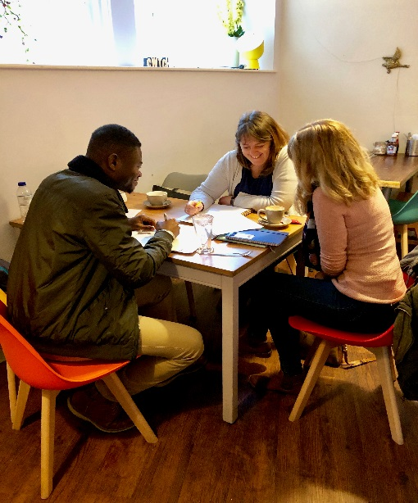

**Plate 1**: Murat discussing the questionnaire and survey implementation strategy with stakeholders.

Due to the complex nature of DWPA, and the failure of earlier approaches (that were top-down, punitive and disjointed) to understanding and influencing farmers’ behaviour regarding the problem, **this PhD research adopts a novel approach that is bottom-up, collaborative and integrative. This has resulted in a collaboration between the University of Leeds and Welsh Water** (awaterutility)**.** The project addresses a direct need of the Welsh Water in trying to understand the effectiveness of their Weedwiper project. The Weedwiper project, launched in 2015 aims at promoting sustainable weed management practices in the Teifi, Upper Wye and Tywi catchments to improve water quality. Weedwiper machines are being offered to farmers for hire. Information packs are also provided to raise farmers’ awareness on pesticide management and effects on watercourses. Welsh Water is interested in understanding how effective the Weedwiper project has been, how to improve it, how to measure/monitor behavioural changes and how to engage farmers.

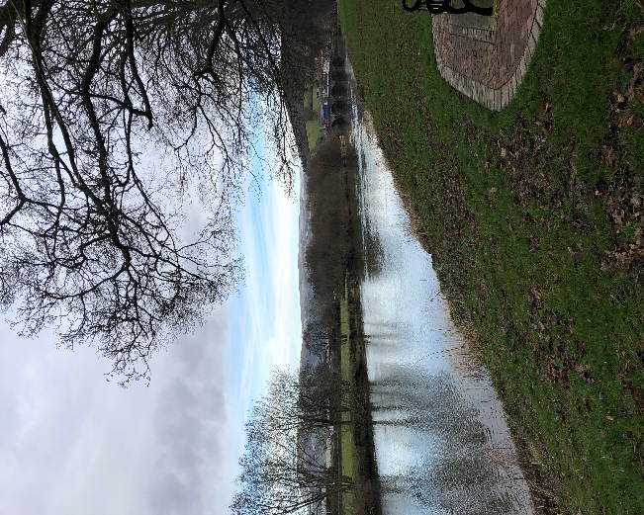

**Plate 2**: A section of River Wye, Builth Wells

In line with this, I co-developed a data collection instrument with Welsh Water and FarmingConnect (a local farmers’ organization). **The funding from Water@leeds enabled me to travel to Wales for a face-to-face discussion with stakeholders from Welsh Water and FarmingConnect, and to pretest my questionnaire with farmers.** This helped to improve the quality and relevance of the instrument, to address the most pressing issues within the Welsh context.

The next steps of my research include **implementation of surveys and analysis of the survey data as well as water quality data.** I will focus on exploring key areas such as effective ways to engage farmers, raise awareness and influence behaviour regarding the application of pesticides; areas to target during interventions, and farmers’ attitudes towards existing DWPA interventions. **I aim to publish the results of the study and acknowledge Water@leeds for the funding and support provided at various stages of my research.**