SPRING AWARD Report 2017, December
Ben Pile
Name:
Impacts of interacting anthropogenic stressors on ecosystem processes in temperate freshwater ecosystems
Thesis Title:
Dr Alison Dunn and Dr Chris Hassall, School of Biology, Faculty of Biological Sciences, Professor Lee Brown, School of Geography
Supervisor, School and Faculty:
The general aim of the project: Freshwater ecosystems maintain clean water supplies, flood protection and food provisioning. These systems are vulnerable to impacts from human activity, which can affect function and productivity. It is important to research how pressures on freshwaters interact to alter these vital ecosystems.
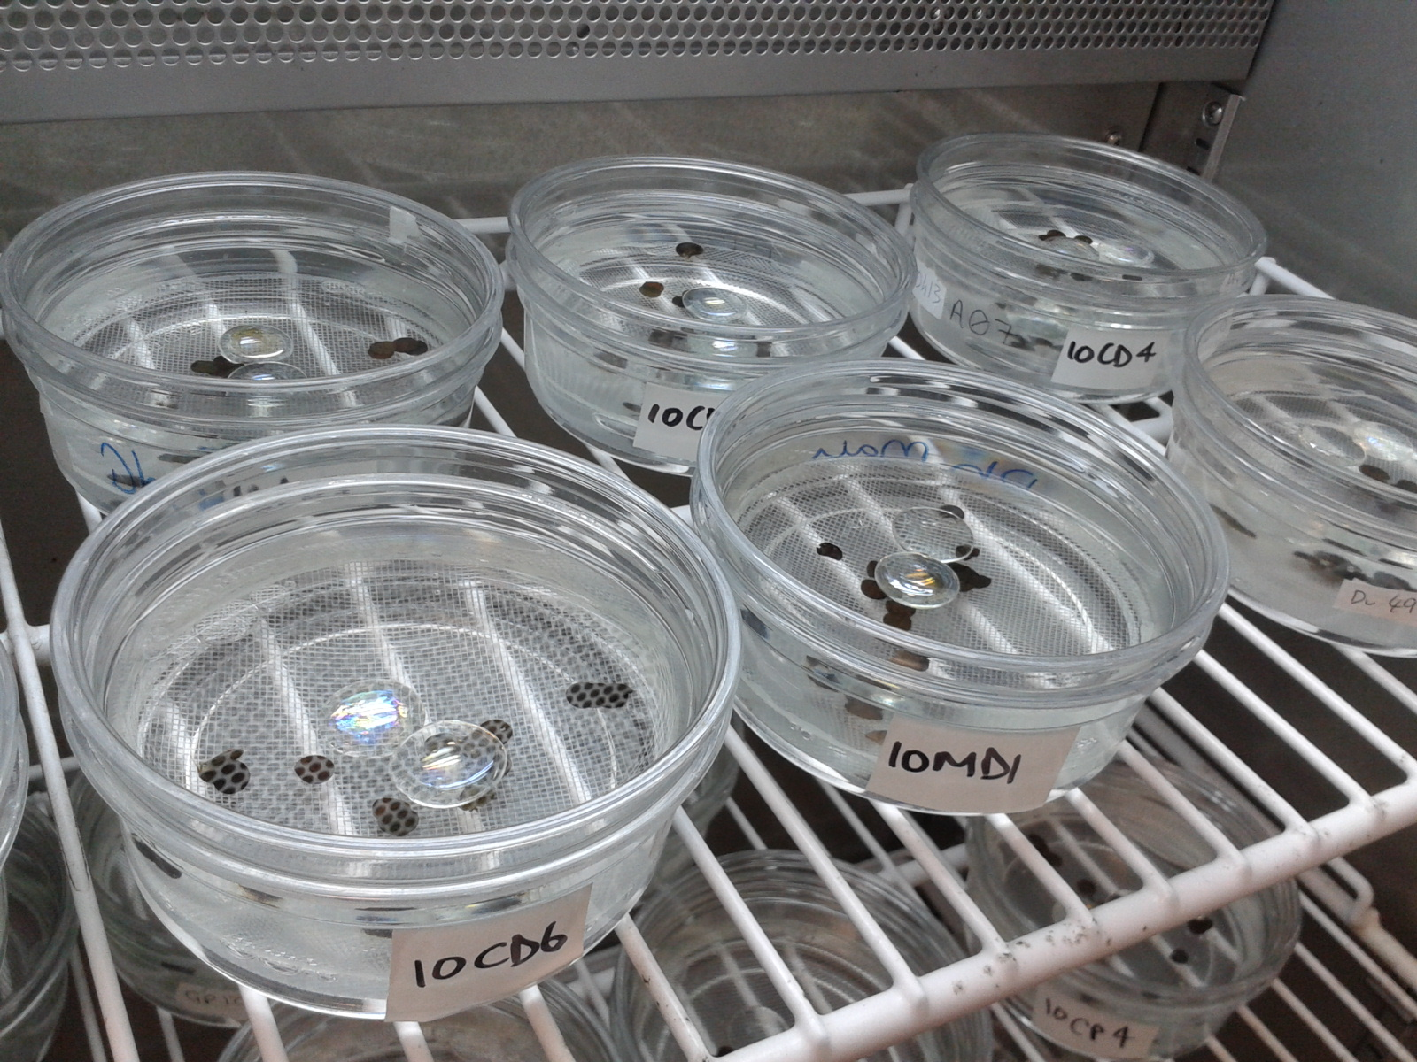
The main challenges: Invasive species are a main driver of biodiversity loss, with freshwaters especially vulnerable. Climate change is an increasing problem, with more extreme events accompanying average warming. I investigate how invasive species and extreme heatwaves interact to affect freshwater ecosystems in the UK.
Amphipod shrimp subjected to a heatwave in an incubator while their survival and leaf consumption are measured
The focus challenge that you are addressing (the smaller bit from the grand challenge): Amphipods are small crustaceans responsible for processing resources that maintain energy flow in freshwaters. I compare native and invasive species and how they react to heatwave temperatures.
What tools you have used and will use: I collected native and invasive amphipods from locations in the UK. These were then tested under different temperature regimes to see how survival and detritus processing are affected by temperature.
What the expected outcomes are: It was predicted that the invasive killer shrimp Dikerogammarus villosus, would process less of the resource than the native, Gammarus pulex, while being more tolerant of high temperatures.
What the actual outcomes were: It was confirmed that the invasive species is better able to survive high temperatures than the native, but processes less of the detrital resource. This may facilitate species replacement, as well as altering future freshwater productivity and quality.
How the SPRING award funds assisted you in reaching your goal for this particular project?
The award enabled me to purchase equipment required for collecting specimens, maintaining them in the lab, and isolating in incubators. I was also enabled to collect from sites around the UK where the different species are present, and purchase equipment to test the detrital outputs.
Why you will recommend PGRs at the water@leeds DRTC to apply to the SPRING funds
The SPRING award is an invaluable source of funding, which can make studies possible which may be unviable without financial support. The continued support of water@leeds for new studies and researchers can make a real difference in this vitally important field of research.

