SPRING AWARD Report [YEAR, MONTH OF COMPETITION]
Lawrence Eagle
Name:
Extreme summer flooding and stream ecosystem processes in Glacier Bay Alaska.
Thesis Title:
Lee Brown, Megan Klaar Jonathan Carrivick – School of Geography
Supervisor, School and Faculty:
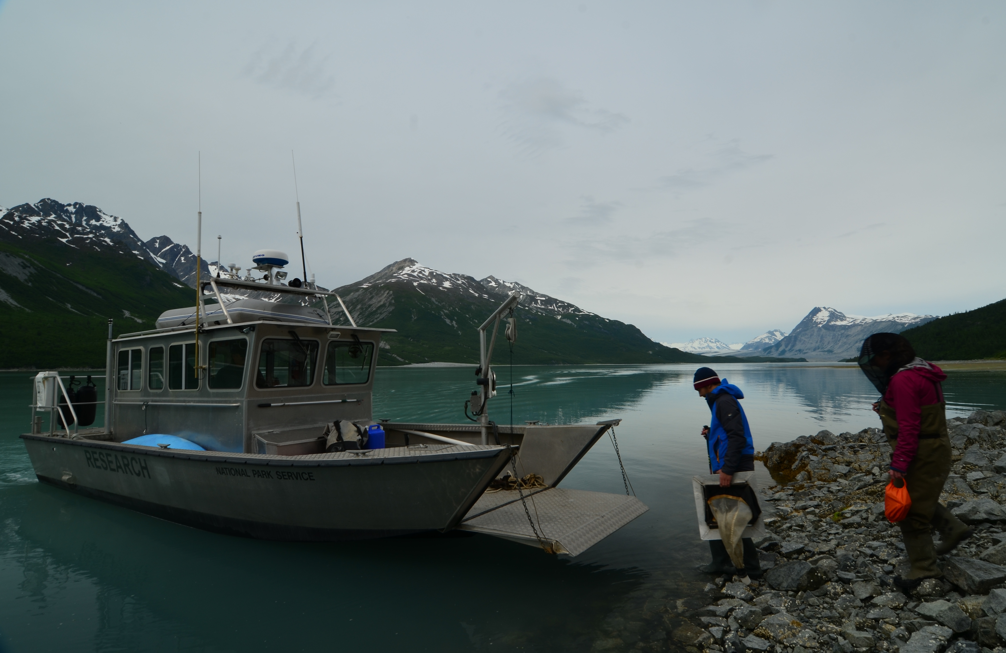
The general aim of the project:
Extreme flooding is becoming more regular under anthropogenic climate change. Climate change is driving fluctuations in the regularity, magnitude and duration of precipitation events. However the ecological impacts of such floods are poorly understood. Work in the field typically focusses on short term community response to floods. This approach fails to address questions regarding the long term ecological recovery of systems. Nor does it consider the relationships between species which occupy disturbed river systems. Finally work tends to focus on individual rivers which prevents understanding of changes in wider regional processes. My research attempts to assess the ongoing response of river ecosystems to persistent flooding during the summer of 2014 in South East Alaska. It will focus on combining community and species analyses with novel ecosystem wide (food web) approaches. This work will be be contextualised with an assessment of geohydrological change within river systems following the floods.
South East Alaska offers opportunities to study ecological systems in their natural condition with little anthropogenic impact. My field sites, within Glacier Bay National Park, represent a novel chronosequence of physical and ecological succession from bare ground to Sitka spruce and western hemlock forests. A similar successional process has been recorded in the regions rivers. The bay is protected as a national park and lies within a UNESCO World Heritage Site and Biosphere Reserve. Its untamed and wild nature allows physical and ecological processes to continue in a natural state. This naturalness provides the opportunity to assess the impacts of climate change driven flooding as a baseline with which to compare and contrast impacts in heavily managed sites found across the world. As such it can play a valuable role in establishing approaches and policy to topical questions regarding the value of river restoration in places such as the Yorkshire Dales where previously complex rivers have been straightened and denude of barriers to flow.
The SPRING award has allowed me to undertake an extended field season through the summer of 2017, during which I have collected a range of physical and ecological data and samples. These alongside preflood samples collected by my supervisors represent the core of my PhD research. I now begin the process of analysing the physical data collected and identifying and analysing the biotic samples collected this summer.

